Lab 3
22k-5195 Laiba Fatima
Class Activity:
One-way:
Server:
import socket
s = socket.socket()
print("Socket created")
s.bind(('localhost', 9999))
s.listen(5)
print("Waiting for connection")
while True:
c, addr = s.accept()
print("Got connection from", addr)
c.send(bytes("Thankyou for connecting", 'utf-8')) # Encoding done correctly here
c.close()
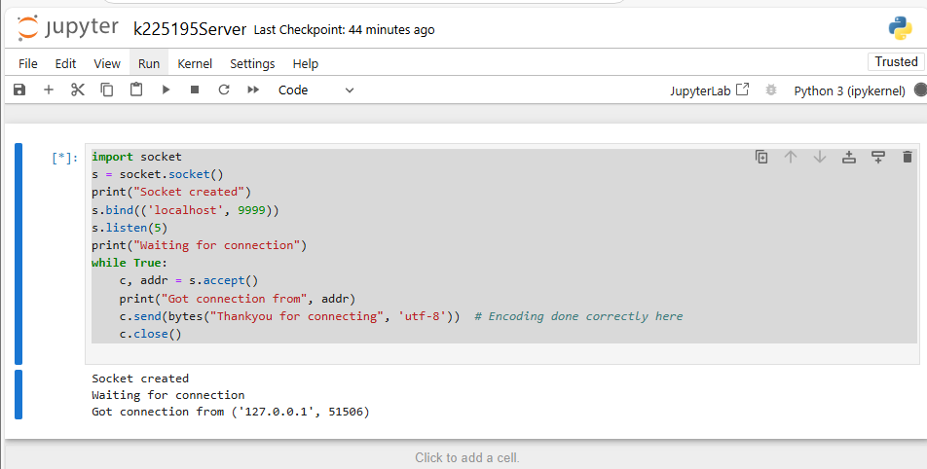
Client:
import socket
s = socket.socket()
s.connect(('localhost', 9999))
print(s.recv(1024).decode("utf-8")) # Decode the message with the same encoding
s.close()
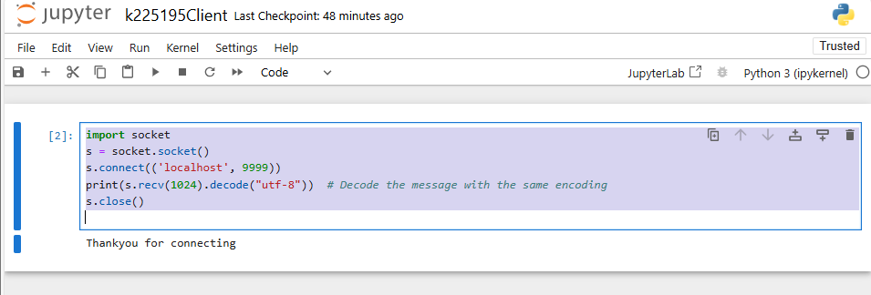
Two-way communication:
Server:
import socket

s = socket.socket()
print("Socket created")
s.bind(('localhost', 8879))
s.listen(5)
print("Waiting for connection")

while True:
c, addr = s.accept()
print("Got connection from", addr)
c.send(bytes("Thank you for connecting", 'utf-8'))

while True:
client_message = c.recv(1024).decode('utf-8')
print("Received from client:", client_message)
if client_message.lower() == "quit":
print("Client sent 'quit'. Closing connection.")
c.send(bytes("Goodbye!", 'utf-8'))
break
else:

server_message = input("Enter message to send to the client: ")
c.send(bytes("Server says: " + server_message, 'utf-8'))

c.close()
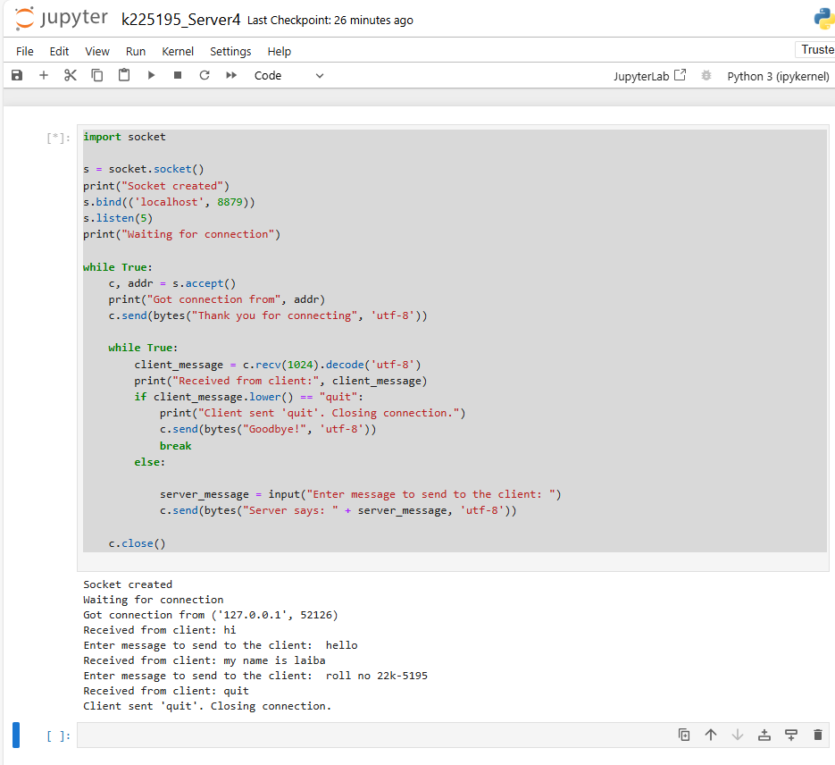
Client:
import socket

s = socket.socket()
s.connect(('localhost', 8879))

server_message = s.recv(1024).decode("utf-8")
print("Server says:", server_message)

while True:
message_to_server = input("Enter message to send to server (type 'quit' to exit): ")
s.send(bytes(message_to_server, 'utf-8'))
if message_to_server.lower() == "quit":
server_response = s.recv(1024).decode('utf-8')
print("Server responded:", server_response)
break
server_response = s.recv(1024).decode('utf-8')
print("Server responded:", server_response)
s.close()
